Front seat covers and upholstery
Removing and installing backrest cover and upholstery with sports seat
Removing
Important
Observe safety precautions for working on airbag =>
- ‒ Remove front seat => Page 72-3.
- ‒ Remove backrest => Page 72-10.
- ‒ Remove head restraints- => Page 72-22.
- ‒ Remove backrest panel => Page 74-9.
- ‒ Removing head restraint guides => Page 72-22.
- ‒ If applicable, detach connector under trim for seat frame. This involves removing outer seat frame trim => Page 72-6.

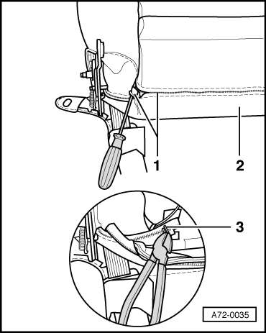
- ‒ → Pull zip -1- out of backrest cover -2-.
- ‒ Pinch off upholstery staples -3- and open zip.

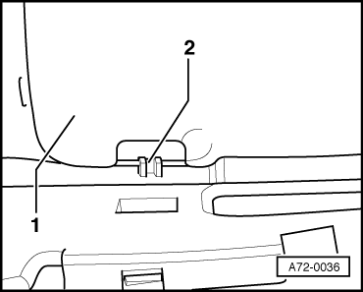
- ‒ → Lift backrest centre section -1- and detach it from backrest catch -2-.
- ‒ Pinch off staples at cover for backrest centre section and detach cover.

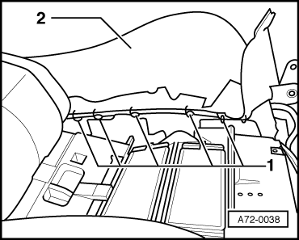
- ‒ → Pinch off staples -1- at cover -2- for side upholstery.
- ‒ Pull up cover over side upholstery until tensioning strap becomes visible.
- ‒ Detach tensioning strap and detach cover.
Installing
Installation is carried out in the reverse order; note the following:
- ‒ Use upholstery stapler V.A.G 1634 to attach staples to cover for side upholstery.

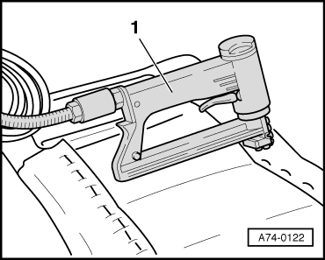
- ‒ → Use commercially available upholstery staple gun -1- to fasten cover for backrest centre section.
- ‒ Make use of upholstery staples as specified by staple gun manufacturer.

- ‒ → Secure zip -1- with upholstery needle and thread.
Important
- ◆ Observe installation instructions for vehicles with side airbag =>Page 69-112.
- ◆ In order to guarantee the function of the side airbag the new upholstery clips must be entered at the same place as before their removal, when working at the backrest cover.
- ◆ Use is only to be made of backrest covers released for side airbags by AUDI AG.
- ◆ Observe seat installation instructions for vehicles with side airbag =>Page 72-5.

