Removing and installing steel wheel bearing housing
Servicing wheel bearing housing with pressed-in wheel bearing

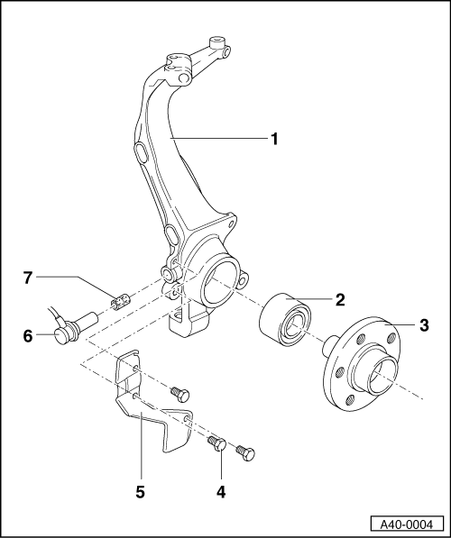
- Wheel bearing housing
For wheel bearing with outer-ø 85 mm, or 82 mm, respectively.
It is permissible to install e.g. ø 85 on left and ø82 on right side.
  - ◆ Removing and installing
=>Page 40-30
- Wheel bearing
  - ◆ Always replace
  - ◆ Installation position:
  - ‒ Large internal diameter of wheel bearing faces wheel hub
  - ◆ Pressing out =>Fig. 2
  - ◆ Pulling off bearing inner race => Fig.3
  - ◆ Pressing in => Fig. 4

- Wheel hub
  - ◆ Stepped version
  - ◆ Pressing out =>Fig. 1
  - ◆ Pressing in => Fig. 5
- Hexagon bolt, 10 Nm
- Cover plate
- Speed sensor
  - ◆ Pull out to remove
  - ◆ Before inserting sensor, clean fitting hole inner surface and coat with lubricating paste G 000 650.
  - ◆ Routing => Page 40-21
- Sleeve
  - ◆ Grease all around with lubricating paste G 000 650 before inserting in wheel bearing housing
  - ◆ Press up to stop into wheel bearing housing

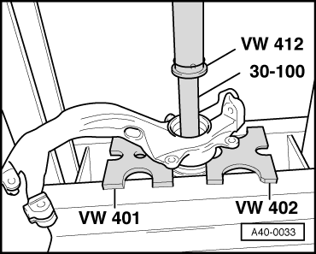
→ Fig.1 Pressing out wheel hub

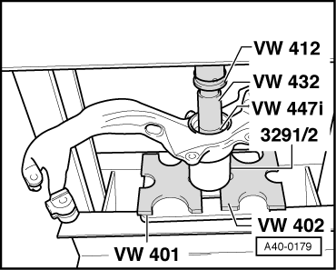
→ Fig.2 Pressing wheel bearing out of wheel bearing housing

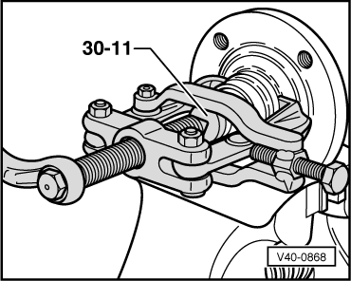
→ Fig.3 Pulling bearing inner race off wheel hub
Always use puller with clamp, e.g. Kukko 204- 1 (commercially available).

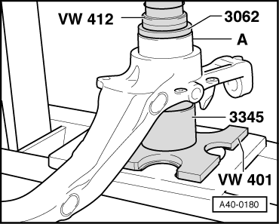
→ Fig.4 Pressing wheel bearing into wheel bearing housing
For wheel bearing with outer-ø 82 mm use the thrust pad -3124-, for outer-ø 85 mm use thrust pad -3062-.
Note:
Large internal diameter of wheel bearing faces wheel hub
- ‒ Press wheel bearing -A- in up to stop.

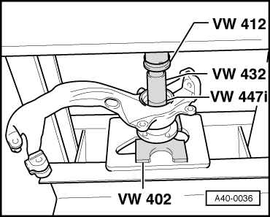
→ Fig.5 Pressing wheel hub into wheel bearing
- ‒ When pressing in, thrust pad -VW 447i- must only make contact with the bearing inner race.

